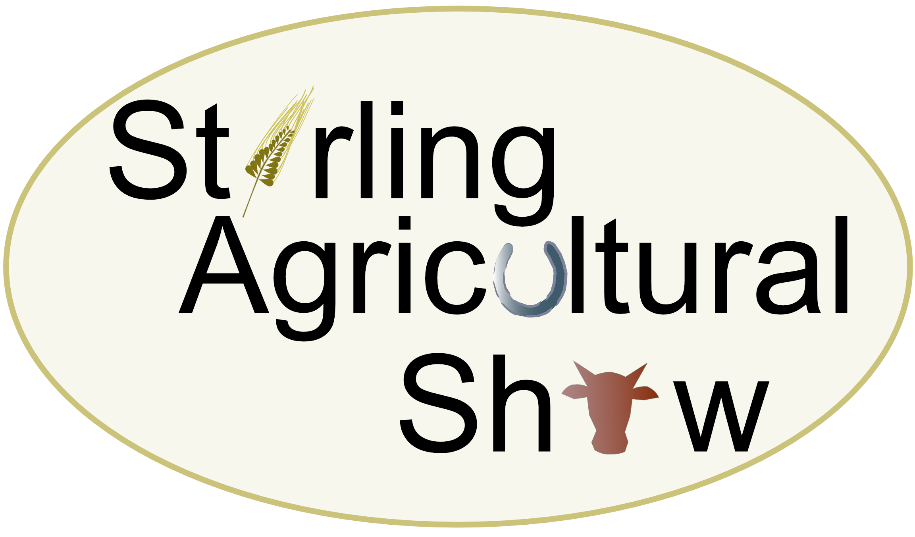

GOGAR MAINS FARM, BLAIRLOGIE, STIRLING, FK9 5QB

SATURDAY 8th JUNE 2024

SHEPHERDS CROOKS AND WALKING STICKS

Entry Fee: £1.00 Membership + 50p per entry

Judge – Mr Gavin McKinlay

Prize Money: £5 for 1st place; £3 for 2nd place; £1 for 3rd place.

DENTS TROPHY : Awarded for Best Exhibit in Show which will qualify for The Scottish Champion of Champions competition. A prize of £20 will be awarded to the Champion stick and £10 awarded to the Reserve Champion. (Sponsored by Joan Dent)

NOVICE CUP : Awarded to the best novice exhibit together with £10 prize sponsored by the Scottish Crookmakers Association and will qualify for the Scottish Novice Champion of Champions competition. Reserve Novice Champion - £5 (Sponsored by Joan Dent)

SCHEDULE

Class 253 | Walking Stick – Plain Horn
Class 254 | Walking Stick – Fancy Horn
Class 255 | Walking Stick – Plain Buffalo
Class 256 | Walking Stick – Fancy Buffalo
Class 257 | Walking Stick – Wood, Plain or Fancy (One or Two Pieces)
Class 258 | Leg Cleek – Horn or Wood (One or Two Pieces)
Class 259 | Sportsman’s Stick
Class 260 | Horn Crook – Plain or Fancy
Class 261 | Wood Crook – Plain or Fancy (One or Two Pieces)
Class 262 | Thumb Stick – Horn or Wood
Class 263 | Novice – Horn Stick – Plain or Fancy
Class 264 | Novice – Wood Stick – Plain or Fancy

RULES:

- All exhibits must be the bona fide work of the Exhibitor in whose name the entry is made.
- All exhibits must be delivered to the Steward no later than 9.30 a.m. on Saturday 8th June 2024.
- Judging shall commence at 10.00 a.m. No exhibits shall be removed before 4.00 p.m.
- No challenge of entries, classification of exhibits, awards of Judges or any other procedure shall be competent after 1.00 p.m. on the day of the show. All challenges must be lodged with the Secretary in writing before that time along with the sum of £5 which will be returned if the objection is sustained.
- Novice stick dressers must not have shown for more than three years.

STIRLING AGRICULTURAL SHOW 2024

SHEPHERDS CROOKS AND WALKING STICKS ENTRY FORM

Class Number | Number of Entries | Entry Fee
 | Membership | £1.00
 | Cost of Entry | £
 | Total Enclosed | £

Entries to be submitted to Joan Dent, 7 Pine Court, Doune, Perthshire, FK16 6JE no later than 1st June 2024. Please make cheques payable to Stirling Agricultural Show.

BACS Transfer details:
The Royal Bank of Scotland
Account No: 00664287
Sortcode: 83-16-03

Name …………………………………………… Signature …………………………….

Address ……………………………………………………………………………………...

Post Code ………………………………… Tel. No………………………………...

