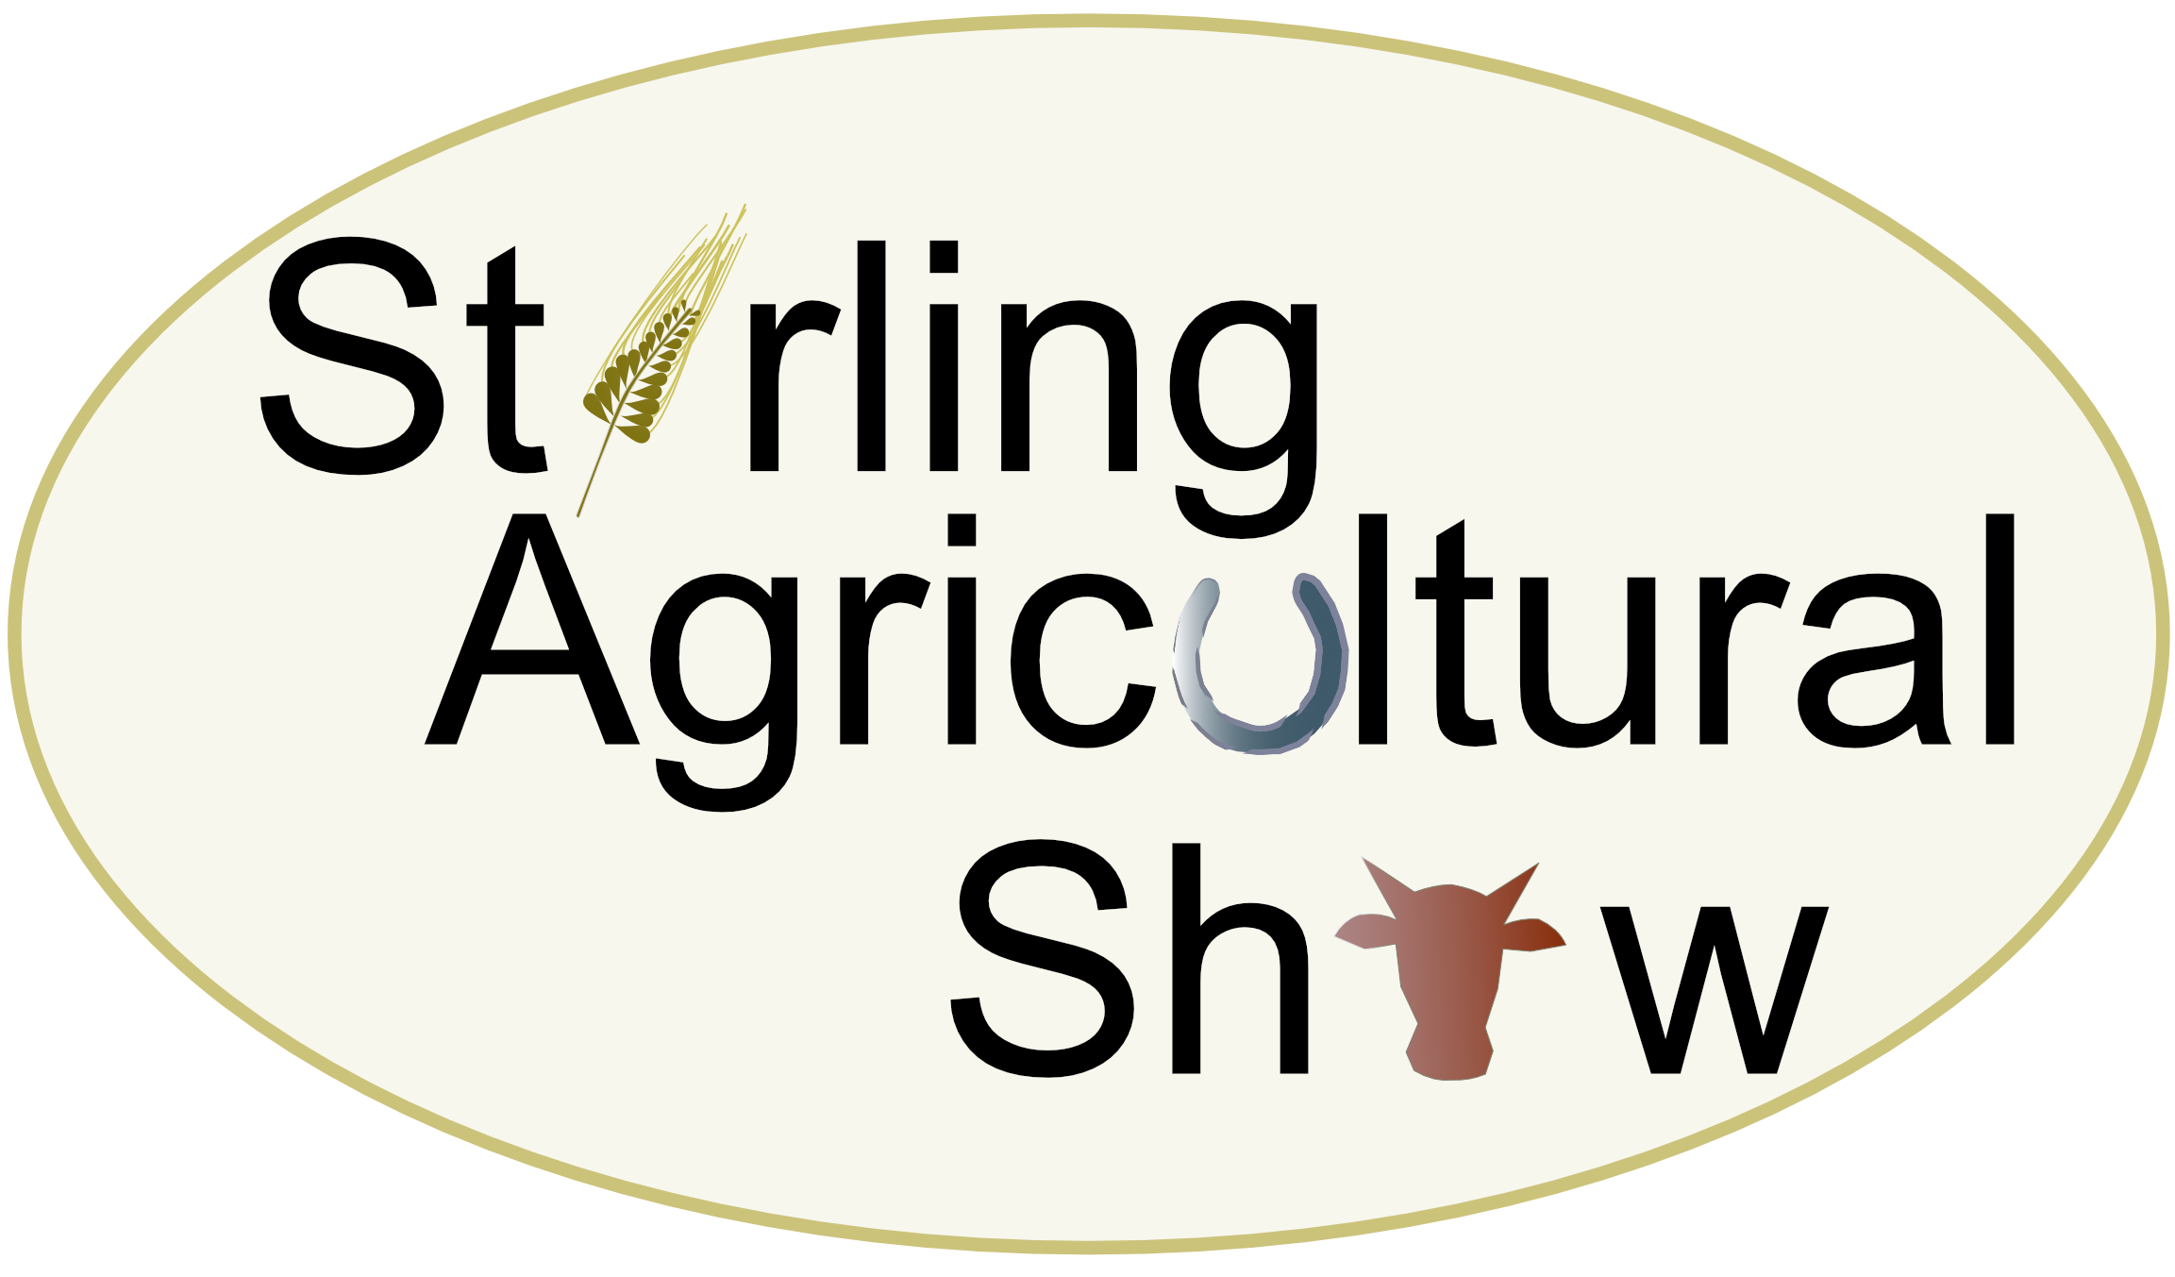

Chairman:
Dexter Logan
Greenhead Farm
Alva
FK12 5QB

Mobile: 07825 178095
Email: dexterkelso123@gmail.com

Secretary:
Jen Murphy
6 Menzies Avenue
Fintry
G63 0YE

Mobile: 07798 895931
Email: secretary@stirlingshow.co.uk

VINTAGE TRACTOR CLASSES – SATURDAY 14th JUNE 2025
Gogar Mains Farrm, Blairlogie, Stirling, FK9 5QB

I write to you on behalf of Stirling Agricultural Show, to invite you to enter Vintage Tractor classes at our 2025 show which will be held on Saturday 14th June 2025, at Gogar Mains Farm, Stirling, by kind permission of Malcolm Snowie and Brian Gilvear.

There is no entry fee, however the closing date for entries is Monday 2nd June 2025, as the catalogue goes to print the following week.

Please return your entries to myself at the above address or enter online at https://stirlingshow.lite.events/ – admission tickets will be sent out the week prior to the show.

Please remember that you must hold a full driving license and all vintage vehicles must be road taxed.

I hope you will be able to join us and help support Stirling Agricultural Show.

Kind regards,

Jen Murphy

Jen Murphy
Show Secretary

-----------------------------------------------------------------------------------------------------------------

VINTAGE TRACTOR ENTRY FORM

Class No. | Class | No. of Entries
VT 1 | Petrol
VT2 | Unrestored
VT3 | Diesel

Name: …………………………………………………………………………………..

Address: ……………………………………………………………………….………..

Post Code: ………………………………….Telephone No: ………

