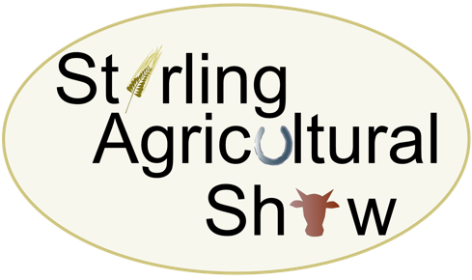
Saturday 10th June 2023
At Gogar Mains Farm, Blairlogie, Stirling, FK9 5QB

CRAFT AND LIFESTYLE STAND BOOKING FORM
To be completed and returned with full payment and all documentation as soon as possible
Trading Name

Address

Post Code

Contact Name & Tel No(s)
Email address(s)

Description of Business/Items for sale
Craft Stall minimum plot – 6’ with 6’ trestle table and 1 chair (£40 per plot) |  | £
Compulsory – Medical Cover per craft stand |  | £2.00
Total Cost |  | £

The following documents MUST be attached to/enclosed with this Craft and Lifestyle Stand Application Form:
Documentation | Attached/Enclosed
Copy of current insurance certificate
A completed Risk Assessment Form
Correct payment amount
Payment Method: Cheque/BACS (delete as appropriate) | BACS / Cheque
Please make any cheques payable to Stirling Agricultural Show
BACS Transfer details: The Royal Bank of Scotland Account No: 00220907 Sortcode: 83-16-03

Signature ……………………………………………………………………………………………………… Date ………………………

