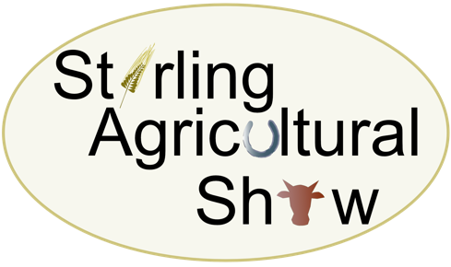
Saturday 13th June 2026

CRAFT AND LIFESTYLE STAND BOOKING FORM
To be completed and returned with all documentation as soon as possible
Trading Name

Address

Post Code

Contact Name & Tel No(s)
Email address(s)

Description of Business/Items for sale
Craft Stall minimum plot – 6’ with 6’ trestle table and 1 chair (£50 per plot) |  | £
Compulsory – Medical Cover per craft stand |  | £2.00
Total Cost |  | £

The following documents MUST be attached to/enclosed with this Craft and Lifestyle Stand Application Form:
Documentation | Attached/Enclosed [P]
Copy of current insurance certificate
A completed Risk Assessment Form
Please make any cheques payable to Stirling Agricultural Show
BACS Transfer: Invoice will be raised on receipt of completed form

Signature ……………………………………………………………………………………………………… Date ………………………

