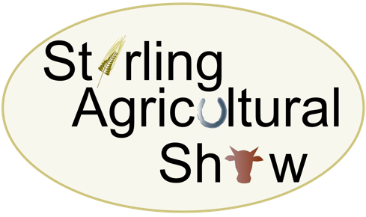
Saturday 10th June 2023
At Gogar Mains Farm, Blairlogie, Stirling, FK9 5QB

FOOD AND DRINK CONCESSION BOOKING FORM
To be completed and returned with full payment and all documentation as soon as possible
Please note that your booking cannot be accepted without the Environmental Health Food Safety Events Form and associated paperwork

Trading Name

Address

Post Code

Contact Name & Tel No(s)
Email address(s)

Description of Business/Items for sale
Plot required (inc vehicles)
Food and Drink Concession as agreed |  | £
Compulsory – Medical Cover per stand |  | £2.00
Total Cost |  | £

The following documents MUST be attached to/enclosed with this Food & Drink Stand Application Form:
Documentation | Attached/Enclosed
Copy of current insurance certificate
A completed Risk Assessment Form
Environmental Health Food Safety Events Form
Correct payment amount
Payment Method: Cheque/BACS (delete as appropriate) | BACS / Cheque
Please make any cheques payable to Stirling Agricultural Show
BACS Transfer details: The Royal Bank of Scotland Account No: 00220907 Sortcode: 83-16-03

Signature ……………………………………………………………………………………………………… Date ………………………

